**DAILY ONLINE ACTIVITIES SUMMARY**

|  |  |  |  |  |  |  |  |  |
| --- | --- | --- | --- | --- | --- | --- | --- | --- |
| **Date:** | **18/05/2020** | | | | | **Name:** | **Spoorthy Balaji** | |
| **Sem & Sec** | **6th & B** | | | | | **USN:** | **4al17cs098** | |
| **Online Test Summary** | | | | | | | | |
| **Subject** | | **CNSC** | | | | | | |
| **Max. Marks** | | **60** | | **Score** | | | **36** | |
| **Certification Course Summary** | | | | | | | | |
| **Course** | **Python for Machine Learning** | | | | | | | |
| **Certificate Provider** | | | **Great Learning Academy** | | **Duration** | | | **5hours** |
| **Coding Challenges** | | | | | | | | |
| **Problem Statement:** Using methods charAt() & length() of String class, write a  program to print the frequency of each character in a string | | | | | | | | |
| **Status: Solved** | | | | | | | | |
| **Uploaded the report in Github** | | | | | **yes** | | | |
| **If yes Repository name** | | | | | **https://github.com/spoorthybalaji/Online-Coding** | | | |
| **Uploaded the report in slack** | | | | | **yes** | | | |

IA TEST

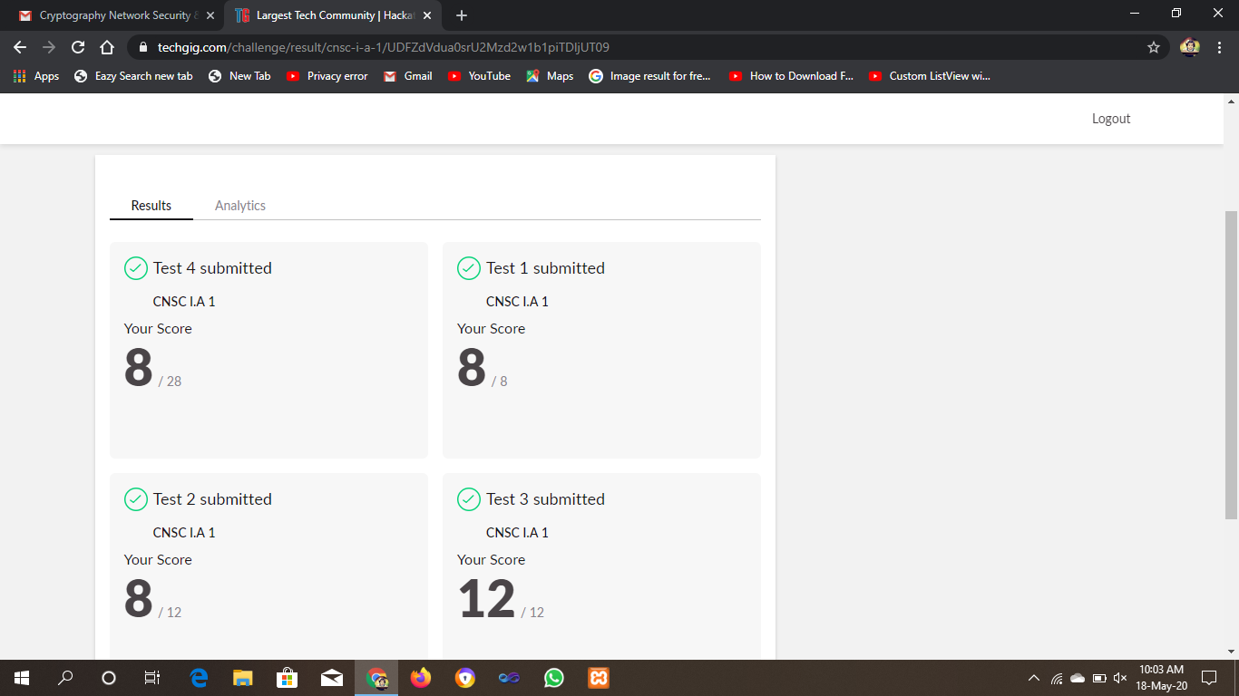

CERTIFICATION COURSE

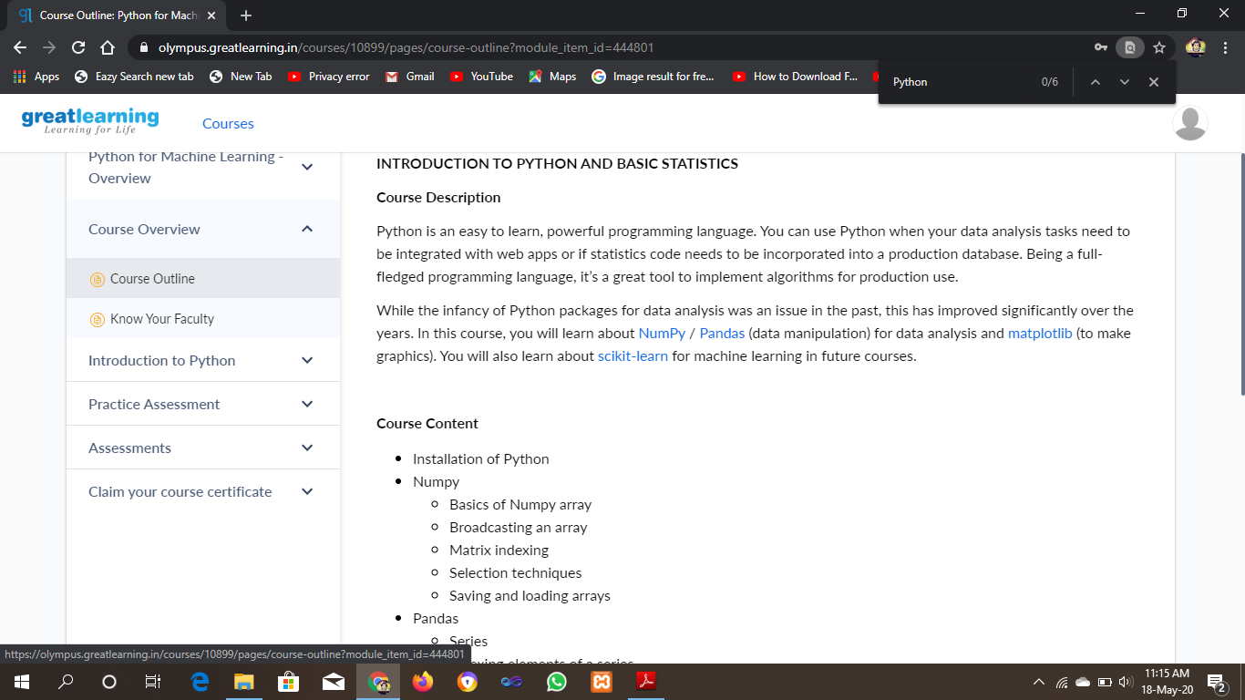

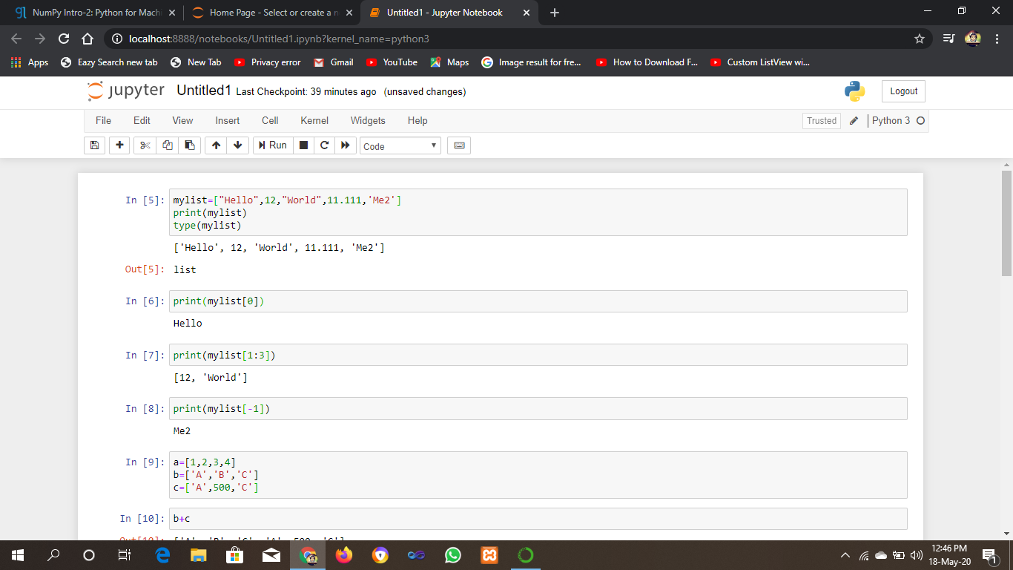

ONLINE CODING

Program1 output:

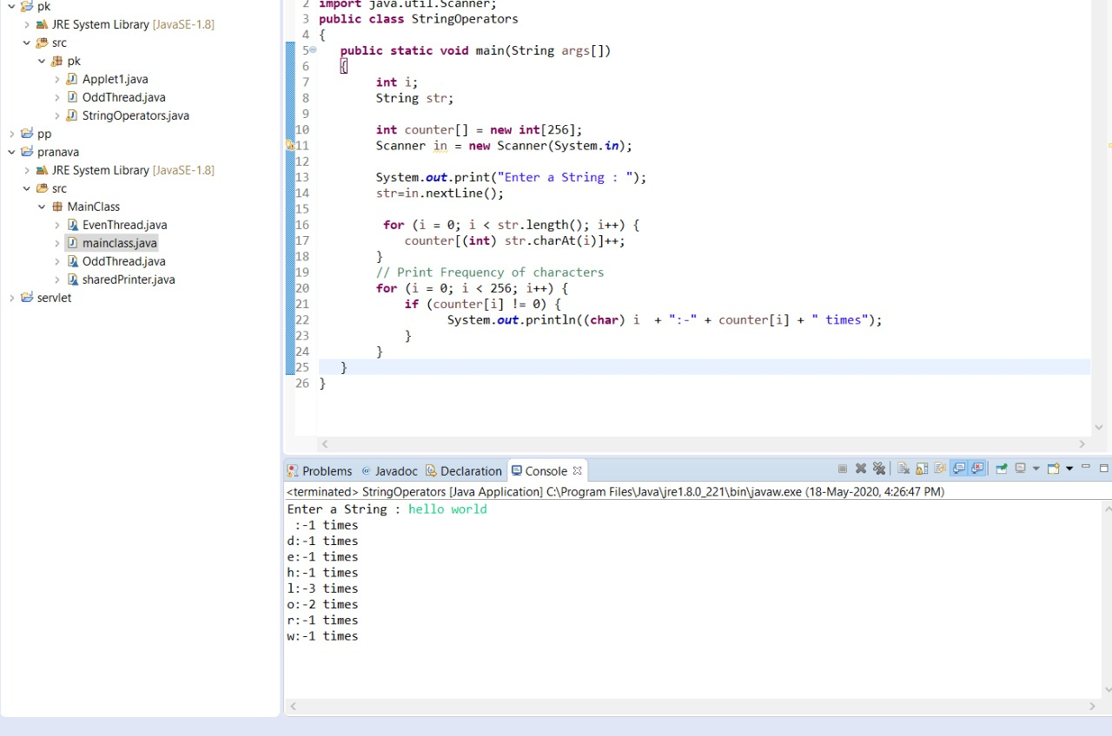

Program 2 output

